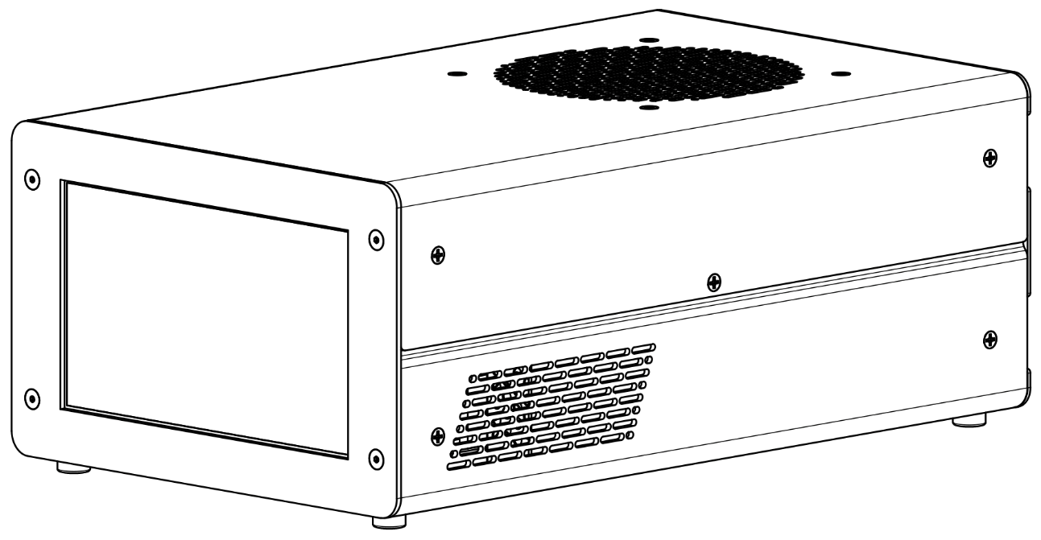
MODION®

PS100 ION PUMP POWER SUPPLY USER MANUAL
Version 0.1

This page intentionally left blank
Contents
1. INFORMATION 7
1.1. NOTICES 7
1.2. PRIOR TO INSTALLATION 7
1.2.1. Storage 7
1.2.2. Unpacking 7
1.3. INSTALLATION 7
1.4. OPERATION 7
1.5. MAINTINANCE 7
Software Updates 7
Cleaning 7
Fuse Replacement 7
1.6. SUPPORT AND SERVICE 8
1.7. WARRANTY 8
2. TECHNICAL DETAILS 9
2.1. SPECIFICATIONS 9
2.1.1. Electrical Specifications 9
Measurement Output Charts 10
High Voltage Output Chart 11
2.1.2. Mechanical Specifications 12
Outside Dimensions 12
Bottom Mounting 13
Front Panel Flange Mount (optional) 14
2.1.3. Rear Panel Description 15
IEC Power Input 15
Ground Stud 15
J1 High Voltage Connector 15
J2 and J3 High Voltage Interlock Connectors 15
J4 Miscellaneous IO Connector 16
J5 Serial Communications Connector 19
J6 Ethernet Connector 19
J7 Wi-Fi Antenna Connector 19
2.1.4. Interlock Circuit 20
2.2. GUI DESCRIPTION 21
2.2.1. Menu Bar 21
2.2.2. Home Screen 21
Chart and Bar Graph Displays 21
Information and Pressure Unit Section 22
High Voltage Enable Button 22
2.2.3. Pump Selection Screen 23
New Pump Screen 24
Edit Pump Screen 25
Edit Pressure Based Voltage Limit Screen 26
2.2.4. Settings Screen 27
Relay Tab 27
Restart Tab 28
Serial Tab 29
Ethernet Tab 30
Wi-Fi Tab 31
System Tab 33
2.2.5. Alarms 34
2.3. REMOTE OPERATION 35
2.3.1. Web Browser 35
2.3.2. Serial Communications 37
Overview 37
Command to Power Supply Message Structure 38
Power Supply Response Message Structure 39
Checksum Calculation 40
Example Serial Transactions 41
2.3.3. User Commands 42
ASCII Reference Table 45
Extended Example Serial Transactions 46

Table of Figures
Figure 2.1.1-1: Electrical specification table 9
Figure 2.1.1-2: Current measurement chart 10
Figure 2.1.1-3: Voltage measurement chart 10
Figure 2.1.1-4: HV Output at various power limits chart 11
Figure 2.1.2-1: Mechanical specification table 12
Figure 2.1.2-2: Outside dimensions 12
Figure 2.1.2-3: Bottom mounting dimensions 13
Figure 2.1.2-4: Front panel mount dimensions 14
Figure 2.1.2-1: Rear panel labeled 15
Figure 2.1.3-2: J4 Misc. IO connector pin numbering 16
Figure 2.1.3-3: J4 Misc. IO connector pin function table 16
Figure 2.1.3-4: Relay pin detail 17
Figure 2.1.3-5: Relay indication detail 17
Figure 2.1.3-6: Open drain pin detail 17
Figure 2.1.3-7: HV Enabled indication pin detail 18
Figure 2.1.3-8: J5 Serial coms connector pin numbering 19
Figure 2.1.3-9: J5 Serial coms connector pin function table 19
Figure 2.2.1-1: Home screen with chart and bar graph displays highlighted 21
Figure 2.2.2-2: Home screen with information section highlighted 22
Figure 2.2.2-3: High voltage enable button with interlock open 22
Figure 2.2.2-1: Pump selection screen 23
Figure 2.2.3-2: Pump selection screen, detail on pressure-based voltage 23
Figure 2.2.3-3: New pump screen 24
Figure 2.2.3-4: New pump screen with current limit input field selected 24
Figure 2.2.3-5: New pump screen, detail on pressure-based voltage 25
Figure 2.2.3-6: Edit pump screen 25
Figure 2.2.3-7: Edit pressure-based voltage limit screen 26
Figure 2.2.4-1: Settings screen, relay tab 27
Figure 2.2.4-2: Settings screen, restart tab 28
Figure 2.2.4-3: HV State Restart truth table 28
Figure 2.2.4-4: Settings screen, serial tab 29
Figure 2.2.4-5: Settings screen, ethernet tab 30
Figure 2.2.4-6: Settings screen, Wi-Fi tab, disconnected 31
Figure 2.2.4-7: Settings screen, Wi-Fi tab, connected 32
Figure 2.2.4-8: Settings screen, system tab 33
Figure 2.2.5-1: Home screen with fan speed alarm active 34
Figure 2.3.1-1: Web interface, HTML version 35
Figure 2.3.1-2: Web interface, GUI version 36
Figure 2.3.2-1: Serial coms field definitions 37
Figure 2.3.2-2: Serial coms Rx message structure, full 38
Figure 2.3.2-3: Serial coms Rx message structure, no data 38
Figure 2.3.2-4: Serial coms Tx message structure, full 39
Figure 2.3.2-5: Serial coms Tx message structure, no data 39
Figure 2.3.2-6: Serial coms Tx message error list 39
Figure(s) 2.3.2-7: Example serial transactions 41
Figure 2.3.3-1: User command table 44
Figure 2.3.3-2: ASCII reference table 45
Figure 2.3.3-3: Extended example serial transactions table 47

INFORMATION

NOTICES
Warnings

PRIOR TO INSTALLATION

Storage
The ideal storage environment is in a cool, dry place out of direct sunlight. Aim for a temperature range of 50-81°F (10-27°C) and humidity levels between 30% and 50%. These conditions help prevent the adverse effects of moisture and heat.

Unpacking
Upon unpacking your new power supply, verify that there is no damage and that all accessories are in the box. It is recommended to save the packaging materials for storage, transporting, or if the power supply needs to be returned.

INSTALLATION
It is crucial that the space remains around the power for proper air flow. Be sure that the openings are not blocked, which could cause improper fan operation.
There are various ways of mounting the power supply. They are tabletop, bottom mount, front panel mount, or 19” rack mount. Please refer to the specific sections for further information.
If using Wi-Fi, locate the Wi-Fi Antenna within the accessory bag and attached at the appropriate location in the back of the power supply.

OPERATION
A basic step-by-step how to start running the power supply, ref. the tech sections.

MAINTINANCE

Software Updates

Cleaning

Fuse Replacement

SUPPORT AND SERVICE
For technical support and warranty inquiries, contact Modion® Customer Support at 724-523-9610 or sales@modionvacuum.com

WARRANTY
Modion® Inc provides a warranty on all commercial products to be free from defects in materials and workmanship for a period of twelve (12) months from the date of shipment to the customer and when used in accordance with these instructions.

Terms
All obligations of Modion® Inc under this warranty shall cease in the event of abuse, alteration, misuse, improper installation, or neglect of equipment. Reasonable care must be taken to avoid hazards. Modion® expressly disclaims responsibility for loss or damage caused by the use of the Modion products other than in accordance with proper operating procedures and conditions.

Modion® Inc ‘s obligation under this warranty is limited to repair or replacement of the Modion® Inc product at Modion® Inc’s option. In no event shall Modion® be liable for any special, indirect, incidental, or consequential damages.

Modion® makes no warranty of merchantability or fitness for any purpose, and no other warranty, oral or written, express or implied, except as specifically set forth in this limited warranty. Neither Modion® representatives nor distributors have any authority of power to alter or extend this limited warranty.

If the customer believes that a defect covered by this limited warranty exists, the customer must return the product to Modion® postage prepaid, along with a description of the problem and proof of purchase and contact information.

For technical support and warranty inquiries, contact Modion® Customer Support at 724-523-9610 or sales@modionvacuum.com

TECHNICAL DETAILS

SPECIFICATIONS

Electrical Specifications
Input Voltage | 100-240 VAC
Input Power | 480 W(max) 24 – 240 W(typical)
Input Frequency | 50/60 Hz
Fuse | 5A Ceramic 5x20 Slow
Operating Temperature | 0 – 50 °C
Storage Temperature | -20 – 60 °C
HV Output Voltage | 5000 VDC Max
Adjustable HV Output Voltage Limit | 500 – 5000 VDC
HV Output Power | 100 W Max
Adjustable HV Output Power Limit | 5 – 100 W
HV Output Current | 100 mA Max
Adjustable HV Output Current Limit | 5 – 100 mA
HV Output Connector | SHV-10
HV Interlock Connector(s) | BNC
HV Interlock Connector(s) | SMB
Current Measurement Output | 0-5 VDC Logarithmic
Current Measurement Resolution | 1 nA
Voltage Measurement Output | 0-5 VDC Linear
Display Type | IPS LCD with Capacitive Touch Screen
Display Size | 7” 800x480
Setpoint Relay | 1 Relay with Additional TTL Output
Setpoint Relay Voltage and Current Rating | 24V 1A
Cooling | 1 Temperature Controlled Fan
Figure 2.1.1-1: Electrical specification table

Measurement Output Charts
Figure 2.1.1-2: Current measurement chart
Figure 2.1.1-3: Voltage measurement chart

High Voltage Output Chart
Figure 2.1.1-4: HV Output at various power limits chart

Physical Specifications
Length | 13.65in [346.8mm]
Width | 8.30in [210.8mm]
Height | 5.44in [138.1mm]
Weight | 8.93lbs [4050g]
Mounting Options | Tabletop
Mounting Options | Bottom Mounting^{(p13)}
Mounting Options | Front Panel Flange Mount^{(p14)} (optional)
Mounting Options | 19” Rack Mount (optional)
Figure 2.1.2-1: Mechanical specification table

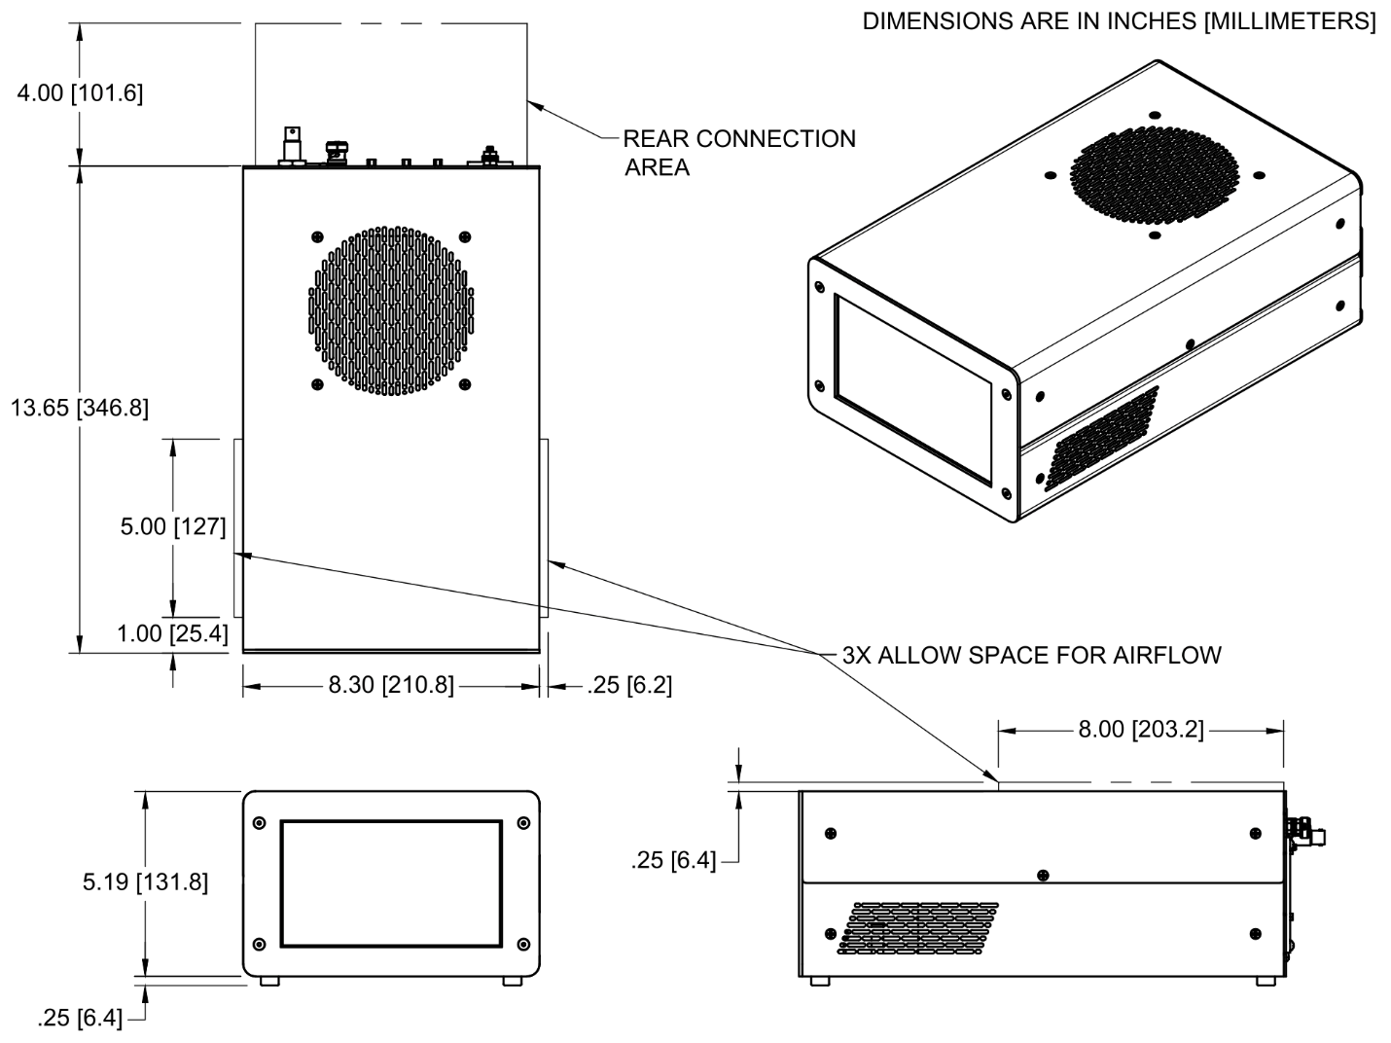
Outside Dimensions
Figure 2.1.2-2: Outside dimensions

Bottom Mounting
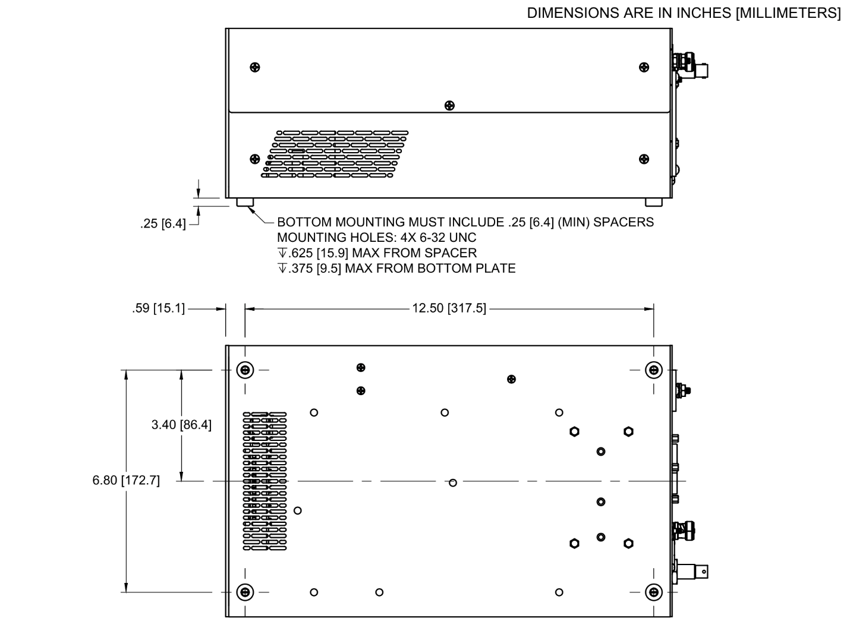
The power supply may be mounted from the bottom by removing the rubber feet. Utilizing those threaded holes with four #6 x 0.25” (1/4”) long spacers (not included) allows space for proper airflow. The maximum length of 6-32 UNC screw that may be threaded into the power supply is 0.375” (3/8”) from the bottom surface.
Figure 2.1.2-3: Bottom mounting dimensions

Front Panel Flange Mount (optional)
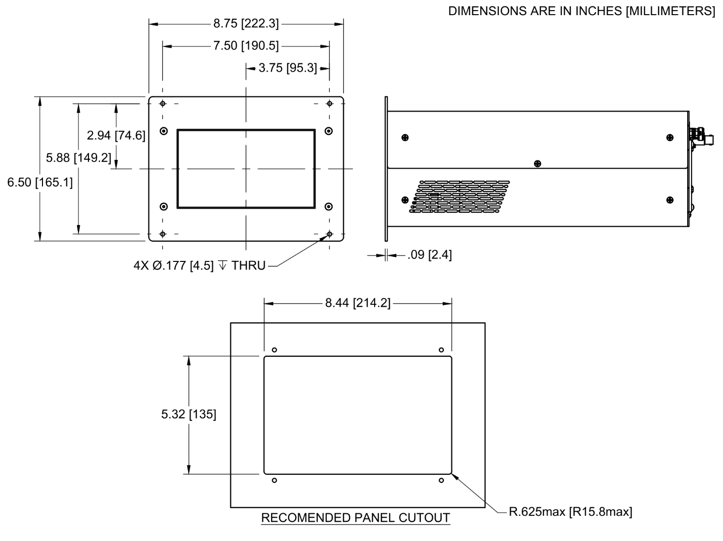
A front panel mount kit is available to mount the power supply into a panel. The holes are sized for #8 or M4 screws.
Figure 2.1.2-4: Front panel mount dimensions

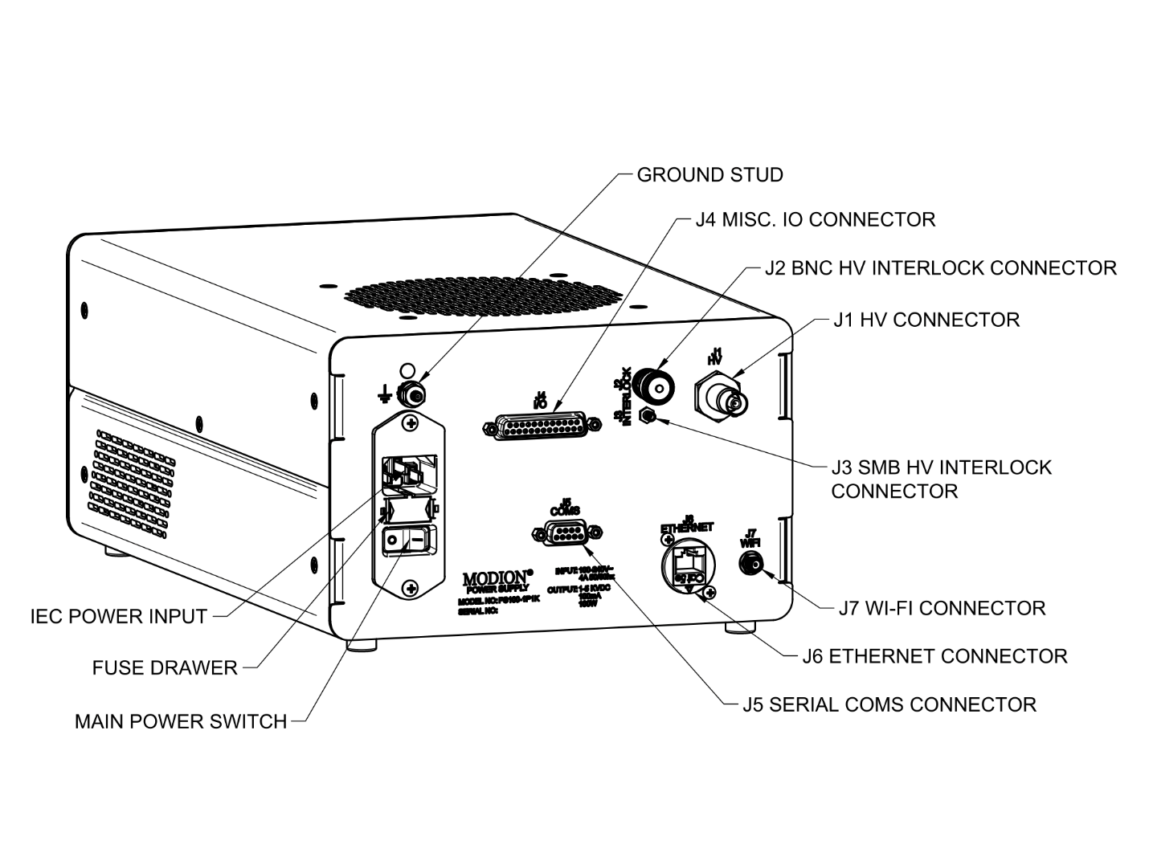
Rear Panel Description
Figure 2.1.2-1: Rear panel labeled

IEC Power Input
A standard IEC C14 power entry module. Use mating C13 cable (included). Also on the power entry module are the fuse drawer^{(p7)} and main power switch.

Ground Stud
#8-32 UNC x 5/8” steel grounding stud that is used for connecting a safety ground from the power supply to an ion pump.

J1 High Voltage Connector
The High Voltage Connector of type SHV-10.

J2 and J3 High Voltage Interlock Connectors
J2 is a BNC coaxial connector and J3 is a SMB coaxial connector. They are wired in parallel internally and either, can be used. A shorting cap for J2 is provided and will be required to use a pump without a safety interlock. Reference the Interlock Circuit^{(p20)} section.

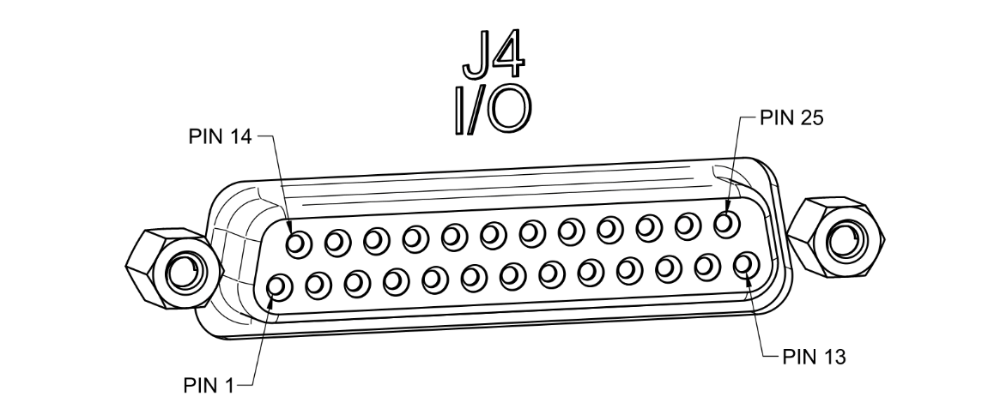
J4 Miscellaneous IO Connector
Figure 2.1.3-2: J4 Misc. IO connector pin numbering

Pin Num. | Function | Remarks
1 | Relay Common | 24V 1A max
2 | Relay Normally Closed | 24V 1A max
3 | User 24V Output | 100mA max
4
5 | Fault Indication | Open Drain, Active Low
6 | Power Limit Active Indication | Open Drain, Active Low
7 | Current Limit Active Indication | Open Drain, Active Low
8 | High Voltage Enabled Indication | 10k Pullup to 5V
9 | Current Measurement Output | Analog 0 – 5 VDC Logarithmic
10 | Voltage Measurement Output | Analog 0 – 5 VDC Linear
11 | Ground
12 | N.C.
13 | N.C.
14 | Relay Normally Open | 24V 1A max
15 | Relay Indication | 5V TTL
16
17
18
19
20
21 | Enable / Disable High Voltage | Active Low, 5V Pullup
22 | Safety Interlock Disable | Active Low, 5V Pullup
23 | Ground
24 | N.C.
25 | N.C.
If function Is N.C. no connection should be made to pin.
If function is blank there is no internal connection to pin.
Figure 2.1.3-3: J4 Misc. IO connector pin function table
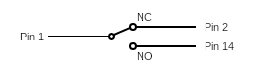
- Setpoint relay – used by making connections to pins 1, 2, and/or 14. The pins have a voltage rating of 24 volts and a current rating of 1A.
Figure 2.1.3-4: Relay pin detail
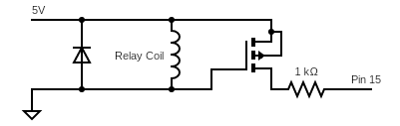
- Relay Indication – a digital output that indicates the state of the relay. It will be pulled to 5VDC when the relay is energized. It is provided by a p-channel MOSFET
across the relay coil. There is a 1kΩ resistor in series with this output.
Figure 2.1.3-5: Relay indication detail
- User 24V Output – provided for convenience and can be used to power low power circuitry. It will output 24VDC whenever the main power switch is in the on position. It has a 100mA current rating and is protected by a PTC resettable fuse in series.
- Power and Current Limits Active Indication – digital outputs that indicate if the high voltage output is being limited by the power limit or by the current limit. They are provided by an open drain n-channel MOSFET. They can sink up to 50mA at 5VDC. If the respective limit is active the pin will be pulled low.
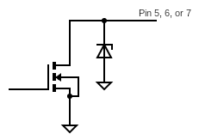
- Fault Indication – This output functions in the same way as the power and current limit indications. Note that the fault indication only indicates an internal power supply fault and will not indicate all alarm messages displayed on the GUI. It will indicate a fault whenever an arc is detected and will be cleared automatically if the arc detention restart function Is active. Reference the Restart Tab^{(p28)} section.
Figure 2.1.3-6: Open drain pin detail
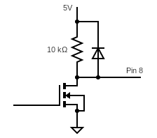
- High Voltage Enabled Indication –indicates the state of the high voltage output. It is pulled to 5VDC with a 10kΩ resistor when high voltage is active and pulled to 0V when the high voltage output is disabled.
Figure 2.1.3-7: HV Enabled indication pin detail
- Current and Voltage Measurement Outputs –provides the high voltage output current and voltage measurements. They can output from 0 to 5VDC and can source up to 2mA. Reference the Measurement Output Charts^{(p10)}.
- Enable / Disable High Voltage –used to enable or disable the high voltage output. It is internally pulled up to 5VDC with a 10kΩ resistor and is activated by pulling to 0V. To enable the high voltage output, it will need to be pulled low for approximately two seconds. The high voltage enable indication can be observed to determine when the high voltage has become active and then this pin can be released. To disable the high voltage output, it only needs to be pulled low once and does not need to be held.
- Safety Interlock Disable – This input is simply in parallel with the interlock connectors J2 and J3 and can be used to disable the safety interlock in place of a shorting cap on J2 if a pump with a safety interlock is not being used. Reference the Interlock Circuit^{(p20)} section.

J5 Serial Communications Connector
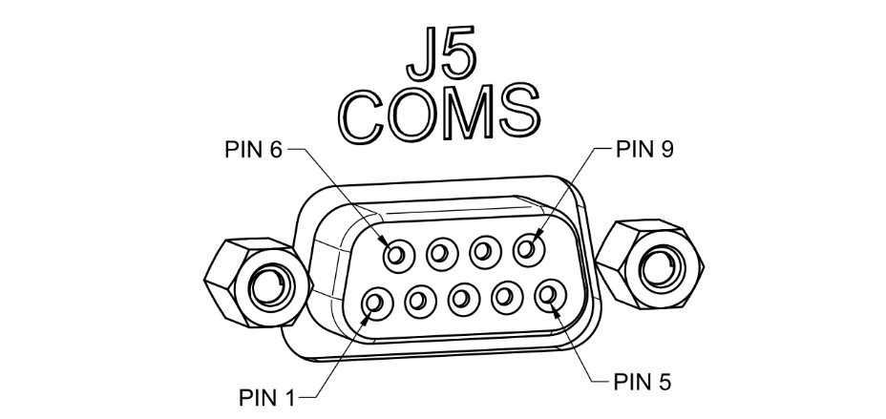
This is a standard DE-9 socket that allows connection to the serial interfaces. Both RS232 and RS485 interfaces share this connector. Only one interface may be used at a time. Note the RS232 pin numbering, connecting to a PC’s com port does not require a null modem cable. There is an internal 121Ω termination resistor across the RS485 A&B pins.
Figure 2.1.3-8: J5 Serial coms connector pin numbering
See the Serial Communications^{(p37)} section for details on using the serial communications.
Pin Num. | Function
1
2 | RS232 Tx
3 | RS232 Rx
4
5 | Ground
6 | RS485 A
7 | RS485 B
8
9
If function is blank there is no internal connection to pin.
Figure 2.1.3-9: J5 Serial coms connector pin function table

J6 Ethernet Connector
A standard RJ45 ethernet socket. Used for REMOTE OPERATION^{(p35)} and Software Updates^{(p7)}. See the Ethernet Tab^{(p30)} section for setting up a connection.

J7 Wi-Fi Antenna Connector
An RP-SMA jack that is used to attach the Wi-Fi antenna (included). Reference section INSTALLATION^{(p7)}. Used for REMOTE OPERATION^{(p35)} and Software Updates^{(p7)}. See the Wi-Fi Tab^{(p31)} section for setting up a connection.

Interlock Circuit
The interlock circuit is an additional input that needs to be connected to ground to enable the high voltage output. The intended purpose is to use a cable that has an additional wire which is connected to the interlock circuit. When the connection to the pump is made it will satisfy the interlock circuit and enable the high voltage output. Thus, if the cables connection to the pump fails it will disable the high voltage output.
There are two connectors on the rear panel where this cable connection can be made, J2 and J3 High Voltage Interlock Connectors^{(p15)}. These are both coaxial connectors with their center contacts connected in parallel to the interlock circuits input. Either can be used for an interlock cable connection.
When not using a cable and connector that incorporate the interlock circuit, the interlock circuit will need to be disabled. There are two ways of achieving this:
- By installing the BNC shorting cap (provided) on the J2 Interlock connector.
- By connecting pin 22 on the J4 Miscellaneous IO Connector^{(p16)} to ground. This pin is also in parallel with the center contacts of J2 and J3.

GUI DESCRIPTION

Menu Bar
The menu bar shown on the left side of the display is used to switch between the three main screens. The Home screen, Pump Selection^{(p23)} screen, and the Settings^{(p27)} screen.

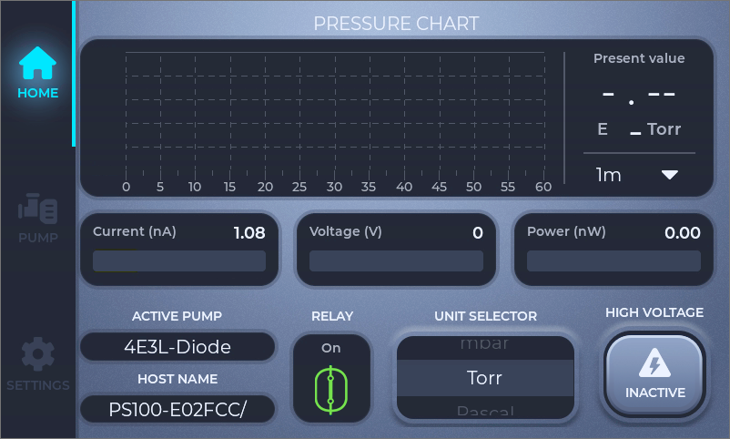
Home Screen
Figure 2.2.1-1: Home screen with chart and bar graph displays highlighted

Chart and Bar Graph Displays
With the high voltage output enabled and a valid pressure reading calculated; the chart will show the pumps pressure, output current, output voltage, or output power over time. Clicking on one of the bar graphs will change which measurement is shown on the chart.
The dropdown next to the time scale shown at the bottom right of the chart allows several different time scales to be selected. There is also an option to clear the chart data; note that this cannot be undone.
Each bar graph except the pressure bar graph displays a value that corresponds to the limit set in the Pump Selection Screen^{(p23)}. For example: If the active pump has a voltage limit of 3KV, the voltage bar graph will display from 0-3KV. The current and power bar graphs always display milliamps and watts respectively, despite the numerical value displaying smaller values. The pressure bar graph’s range is fixed and displays from 1E-10 to 1E-5 Torr.
The limit that is actively limiting the output (current, voltage, or power) will be shown by underlining the numerical value shown next to its bar graph or chart.

Information and Pressure Unit Section
Figure 2.2.2-2: Home screen with information section highlighted
Active Pump: The active pump from the Pump Selection Screen^{(p23)}.
Host Name: The power supply’s network host name. This can be used to connect to the power supply over the ethernet or Wi-Fi. See the REMOTE OPERATION^{(p35)} section for usage.
Relay: Displays the status of the setpoint Relay^{(p27)}.
Unit Selector: Used to select the pressure units used by the power supply.

High Voltage Enable Button
This button is used to enable or disable the high voltage output and to display the status of the interlock circuit. To enable the high voltage output, press and hold the button for several seconds. To disable the high voltage output, press the button once.

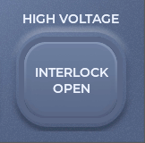
If “INTERLOCK OPEN” is displayed, the Interlock Circuit^{(p20)} will have to be satisfied before the high voltage output can be enabled.
Figure 2.2.2-3: High voltage enable button with interlock open

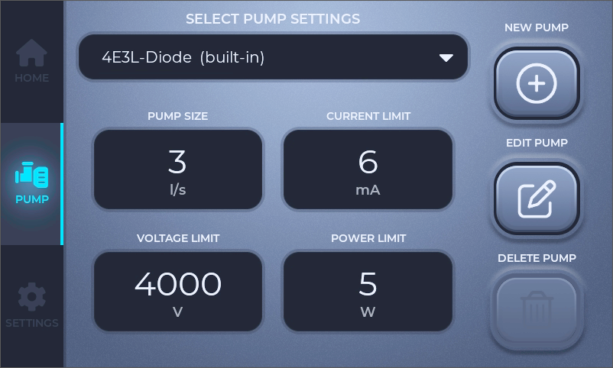
Pump Selection Screen
Figure 2.2.2-1: Pump selection screen
This screen is used to select, edit, or create a ‘pump’ that will set:
- The pump size used for the current to pressure calculation
- The output current limit
- The output voltage limit
- The output power limit
- The pressure adjustment factor that can be used to adjust the pressure calculation
Clicking on the “SELECT PUMP SETTINGS” dropdown will open a list of built in pumps and any that have been created. Selecting one from the list will load its parameters, note that if the high voltage is active this will immediately change the output.
Clicking on any of the parameter boxes will open the Edit Pump screen with that parameter’s input field selected.
The “NEW PUMP” and “EDIT PUMP” buttons will open their respective screens. When creating a new pump, its parameters will be preloaded from whichever pump is currently selected. Since the built-in pumps cannot be overwritten, this can be used to quickly create a copy of the pump and make changes.
The “DELETE PUMP” button will delete the selected pump, note that “built-in” pumps cannot be deleted.
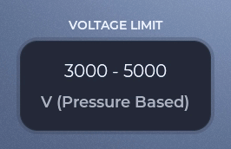
When the pressure-based voltage limit is activated for a pump, the “VOLTAGE LIMIT” box will show the minimum and maximum range of voltage limits that will be set based on pressure for that pump.
Figure 2.2.3-2: Pump selection screen, detail on pressure-based voltage

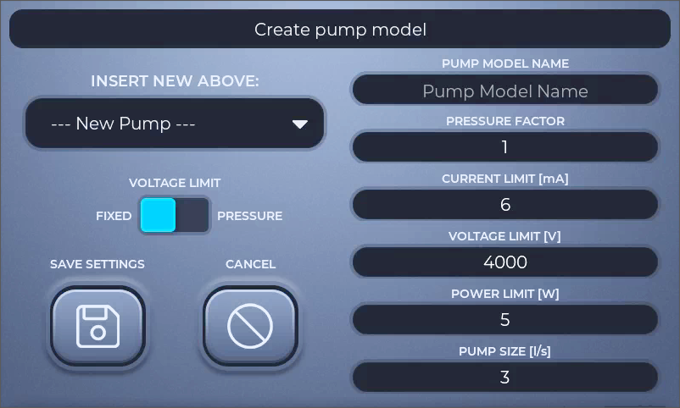
New Pump Screen
Figure 2.2.3-3: New pump screen
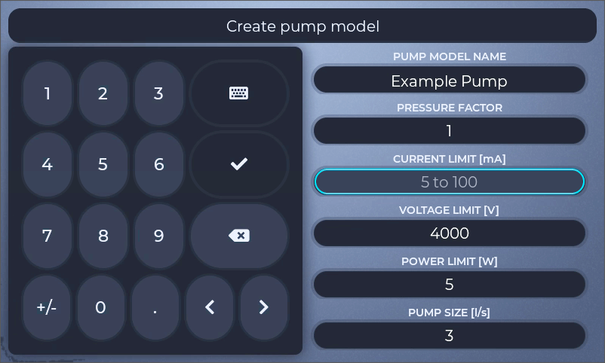
On this screen all the parameters for a pump can be entered by clicking on an input field and using the on-screen keyboard to enter the desired value. The “INSERT NEW ABOVE” dropdown controls where in the list of pumps the new one will be saved. By default, the selection is “--- New Pump ---” which will save the pump at the bottom of the list. Note that user created pumps must be saved below the “built-in” pumps.
Figure 2.2.3-4: New pump screen with current limit input field selected

Clicking on a field will open the on-screen keyboard, clear the field, and show the acceptable range of values [Figure 2.2.3-4]. Use the on-screen keyboard to enter a new value in the acceptable range. If the field was selected by mistake, clicking a different field or closing the on-screen keyboard will replace the value that was previously in the field.
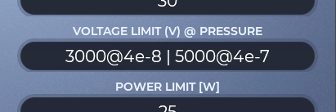
Clicking on the “VOLTAGE LIMIT” toggle will switch between using a fixed voltage limit or a pressure-based voltage limit. If this toggle is set to “PRESSURE”, clicking on the “VOLTAGE LIMIT” field will open the Pressure Based Voltage Limit^{(p26)} screen.
When the pressure-based voltage limit is activated for a pump, the “VOLTAGE LIMIT” box will show a short-hand form of the [voltage]@[pressure] points that will be set based on pressure for that pump.
Figure 2.2.3-5: New pump screen, detail on pressure-based voltage

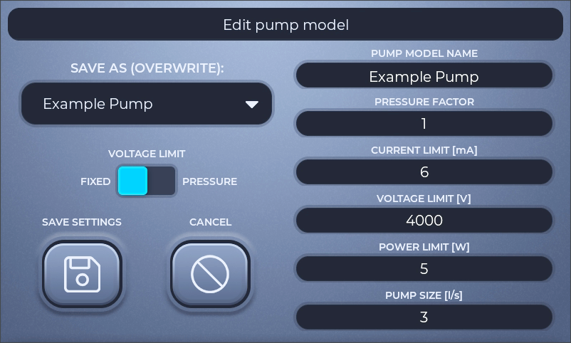
Edit Pump Screen
Figure 2.2.3-6: Edit pump screen
The Edit Pump Screen is very similar to the New Pump Screen^{(p24)}, the main difference is instead of inserting a new pump in the list it will overwrite the pump selected by the “SAVE AS” dropdown. Note that “built-in” pumps cannot be overwritten.
The option to create a new pump at the end of the list is also provided on this screen and can be accomplished by selecting “--- NEW PUMP ---” in the “SAVE AS” dropdown.

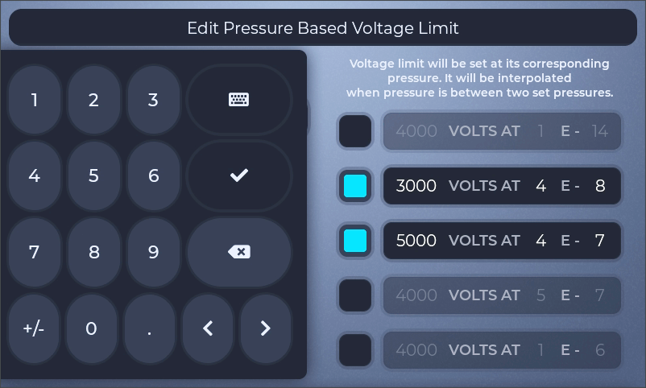
Edit Pressure Based Voltage Limit Screen
Figure 2.2.3-7: Edit pressure-based voltage limit screen
This screen is used to edit the pressure-based voltage limits for a pump. It allows up to five different points to be set. Each point may be enabled or disabled by using the checkbox on the left side of the input field. Values are entered by clicking on the voltage value, significand, or exponent and entering a new value using the on-screen keyboard.
To close this screen and return to the new/edit screen use the check or keyboard button on the on-screen keyboard. Note that when closing this screen, the five points will be automatically sorted based on the pressure value from smallest to largest.
The rules used by the power supply to set the voltage limit based on these points are as follows:
- When the pump’s calculated pressure is greater than the largest active set pressure point, the voltage limit will be set to that point’s voltage value.
- When the pump’s calculated pressure is less than the smallest active set pressure point, the voltage limit will be set to that point’s voltage value.
- When the pump’s calculated pressure is equal to any active set pressure point, the voltage limit will be set to that point’s voltage value.
- If only one point is enabled, the voltage limit will be set to that point’s voltage value.
- When the pump’s calculated pressure is in between two active set pressure points, the voltage limit will be set to an interpolated value between the two points.
The interpolation function is equivalent to finding the logarithmic trendline between the two points and using the equation of that curve to solve for voltage.
Two points with equal voltage and different pressure values may be entered and set as active to maintain a constant voltage limit between those pressures.
Two points with equal pressure values should not be entered and set as active, the power supply may choose to use either point at that pressure.

Settings Screen
The various settings pages are accessible by clicking on the tabs shown at the top of the screen.

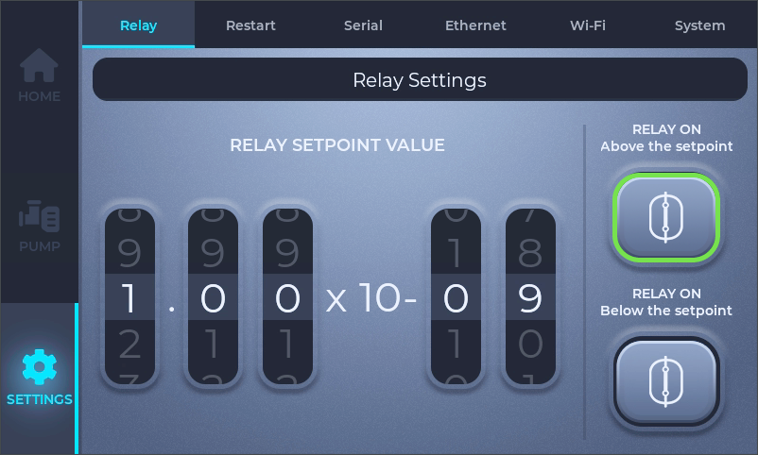
Relay Tab
Figure 2.2.4-1: Settings screen, relay tab
The setpoint value is the pressure where the relay will change state and is entered by selecting the desired pressure using the roller widgets. The set pressure takes effect and is saved immediately. The relay can be energized when the current pressure is above or below the setpoint and is set by selecting the corresponding button.
When the current pressure is above the setpoint and decreases below the setpoint, the relay will change state at exactly the setpoint. When the current pressure is below the setpoint and increases above the setpoint, the relay will change state when the current pressure equals:
$$\left(setpoint\right)*10\%+(setpoint)$$
When the high voltage is disabled, or when it is enabled but prior to a pressure reading being calculated, the relay will be in the high-pressure state. I.e. if it is set to “Above the setpoint” and the high voltage is off, the relay will be energized.
The relay’s normally open and normally closed contacts are available for use on the J4 Miscellaneous IO Connector^{(p16)}.

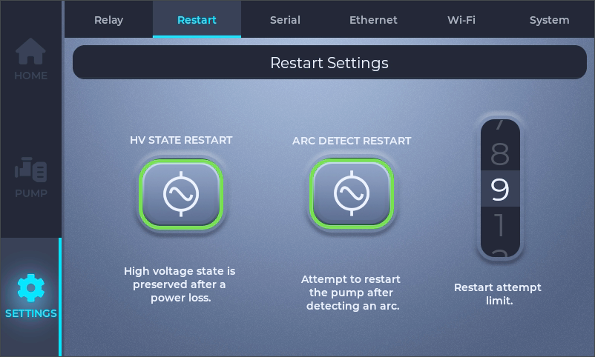
Restart Tab
Figure 2.2.4-2: Settings screen, restart tab
The restart tab is used to control the high voltage restart and arc detection restart functions.
The “HV STATE RESTART” function can be used to enable the high voltage output as soon as input power is applied to the power supply, and functions according to the following table:
High voltage state on power loss | “HV STATE RESTART” setting | High voltage state on power up
Enabled | Enabled | Enabled
Enabled | Disabled | Disabled
Disabled | Enabled | Disabled
Disabled | Disabled | Disabled
Figure 2.2.4-3: HV State Restart truth table
The “ARC DETECT RESTART” function, when enabled, will attempt to re-enable the high voltage output after an arc has been detected. When this is disabled, if the power supply detects an arc on the high voltage output it will disable the high voltage output and will need to be re-enabled manually via the high voltage enable button on the Home Screen^{(p21)} or via one of the REMOTE OPERATION^{(p35)} interfaces.
When this is enabled, if the power supply detects an arc on the high voltage output it will temporarily disable the high voltage output, wait until the voltage decays to zero, and then automatically re-enable the high voltage output. The “Restart attempt limit” is the number of times the high voltage output will be automatically re-enabled before staying disabled and needing to be manually re-enabled.
A period of time after using one of the restart attempts, the power supply will subtract one from the internal count. This will prevent an infrequent arcing issue from disabling the high voltage output.

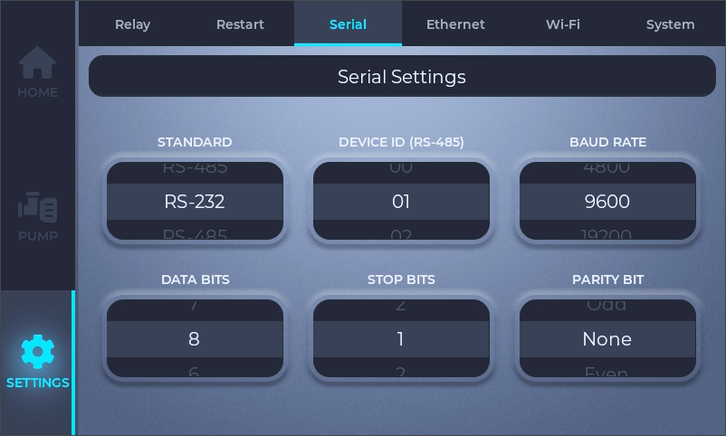
Serial Tab
Figure 2.2.4-4: Settings screen, serial tab
The serial tab controls the serial interface configuration settings. Use the roller widgets to select the desired values, they take effect and are saved immediately. See the Serial Communications^{(p37)} section for further details.

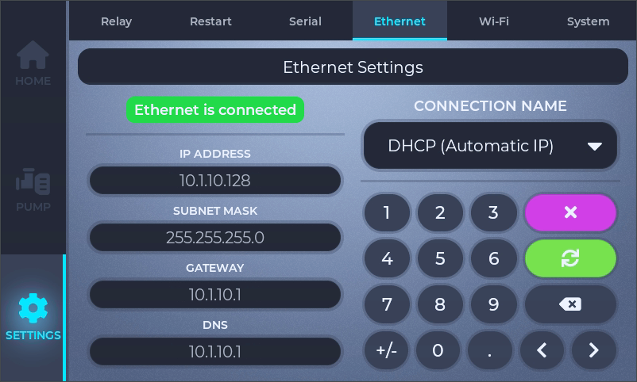
Ethernet Tab
Figure 2.2.4-5: Settings screen, ethernet tab
The ethernet tab displays and is used to connect and disconnect the ethernet interface. By default, the “CONNECTION NAME” dropdown is set to DHCP, and the power supply should automatically negotiate with the router and connect as soon as an ethernet cable is connected. The connection status is shown in the upper left corner of the tab with “Ethernet is connected | disconnected”.

The close button is used to disconnect an active ethernet connection.

The refresh button is used to update a connection after changing parameters.
If it is desired to set up a fixed ethernet IP address; select “Ethernet (Manual)” with the “CONNECTION NAME” dropdown, enter appropriate values in the four input fields, then use the refresh button to open the connection.
The ethernet tab is also used in combination with the Wi-Fi tab to set up a fixed Wi-Fi IP address. Select “Wi-Fi (Manual)” with the “CONNECTION NAME” dropdown, enter appropriate values in the four input fields, switch to the Wi-Fi Tab^{(p31)} and follow the instructions for connecting to Wi-Fi to open the connection.

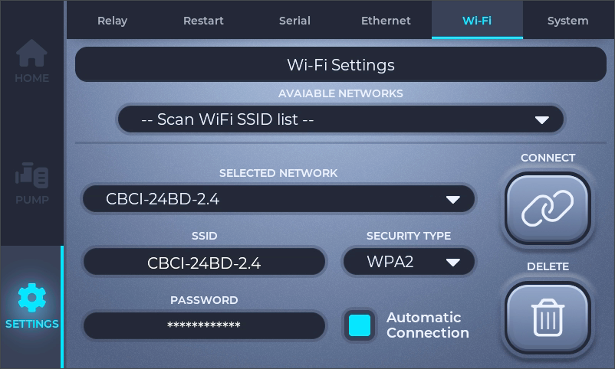
Wi-Fi Tab
Figure 2.2.4-6: Settings screen, Wi-Fi tab, disconnected
The Wi-Fi tab is used to set up, open a Wi-Fi connection, and displays information on an active connection.
To connect to a network:
- Click the “AVAILABLE NETWORKS” dropdown to scan for available networks.
- Select the desired network from the list.
- Enter the password.
- Activate the “Automatic Connection” check box if it is desired for the power supply to re-connect to this network on power up.
- Click the “CONNECT” button.
Note that “SECURITY TYPE” will automatically select the highest level of security available for the selected network, however it can be changed if necessary.
It is possible to connect to a hidden network. Instead of using the “AVAILABLE NETWORKS” dropdown, click on the “SSID” input field and type in the SSID using the on-screen keyboard. Then continue from step 3 above.
Once connected, the new network will be saved in the “SELECTED NETWORK” dropdown. Any saved networks can be removed from the list by clicking on the “DELETE” button. To reconnect to a saved network select it using the “SELECTED NETWORK” dropdown and click connect.

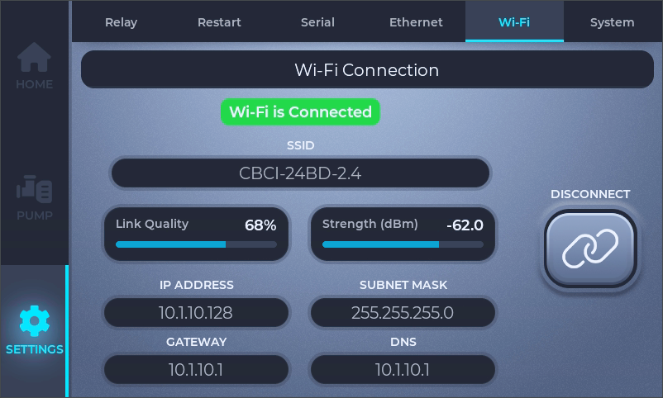
Once connected to a Wi-Fi network the connected page (above) will be shown under the Wi-Fi tab. It shows the connection parameters and two different measurements of the connection quality. Click the “DISCONNECT” button to disconnect and return to the Wi-Fi setup page.
Figure 2.2.4-7: Settings screen, Wi-Fi tab, connected

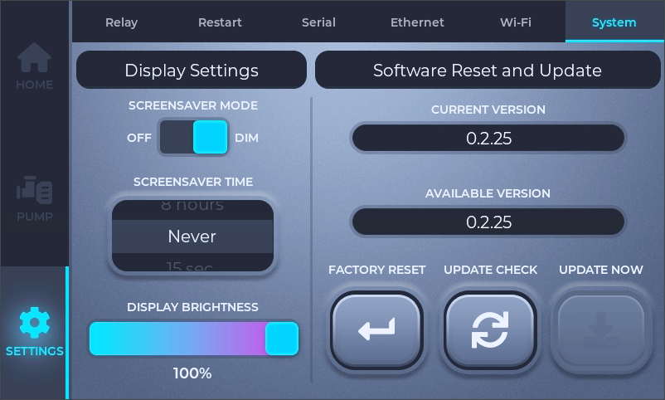
System Tab
Figure 2.2.4-8: Settings screen, system tab
The system tab has controls for the display, a factory reset option, and the software update function.
The “SCREENSAVER MODE” toggle can be set to “OFF” or “DIM”. The ”SCREENSAVER TIME” roller has several different time options to choose from, along with a “Never” option. When the set amount of time has passed without any interaction with the touch screen, the lcd will, depending on the position of the “SCREENSAVER MODE” toggle, either turn off completely or reduce the brightness of the backlight to 1%. Touching the display will return the lcd to the previous brightness setting.
The “DISPLAY BRIGHTNESS” slider controls the normal backlight level.
Holding the “FACTORY RESET” button for several seconds will: return all settings to factory default, delete all user created pumps (the built-in pumps will not be deleted), and remove any saved network connections.
The current software version is shown in the “CURRENT VERSION” field. If there is an active network connection (ethernet or Wi-Fi) with access to the internet, and a new update is available, the software can be updated by using the “UPDATE NOW” button.
The only instance when the power supply will automatically check for a new update is when the system tab is opened. The “UPDATE CHECK” button provides an equivalent functionality.

Alarms
The power supply will generate an alarm for the following conditions:
- The cooling fan speed is lower than the programed speed.
- The internal battery is failing.
- An over-temperature warning and is reducing the output power.
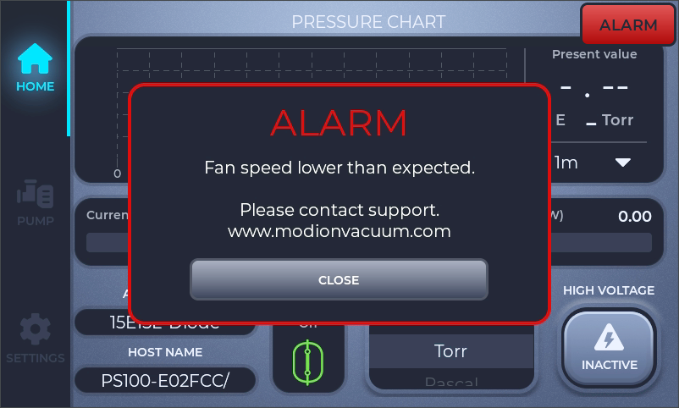
- Over-temperature and is disabling the high voltage output.
Figure 2.2.5-1: Home screen with fan speed alarm active
The red “ALARM” button in the upper right of the display indicates that an alarm is active. When an alarm becomes active the alarm message box will be displayed. Pressing the close button on the message box will close the message box and suppress further message boxes for eight hours, except for the temperature alarms, which will suppress the message box for one hour.
The red “ALARM” button will continue to be displayed on the home screen until the condition causing the alarm is resolved. Pressing the button will un-suppress and open any message boxes that have been suppressed.
Refer to the SUPPORT AND SERVICE^{(p8)} section for troubleshooting and support information.

REMOTE OPERATION

Web Browser
When connected to the ethernet or Wi-Fi, the power supply may be remotely controlled via a web browser. To connect to the power supply, open a web browser and do one of the following:
- Navigate to the power supply’s host name shown on the home screen’s Information and Pressure Unit Section^{(p22)}. Be sure to include the trailing forward slash.
- If there is any issue connecting with the host name the power supply can also be reached by entering the IP address shown on the Ethernet Tab^{(p30)} or Wi-Fi Tab^{(p31)} depending on which interface has an active connection.
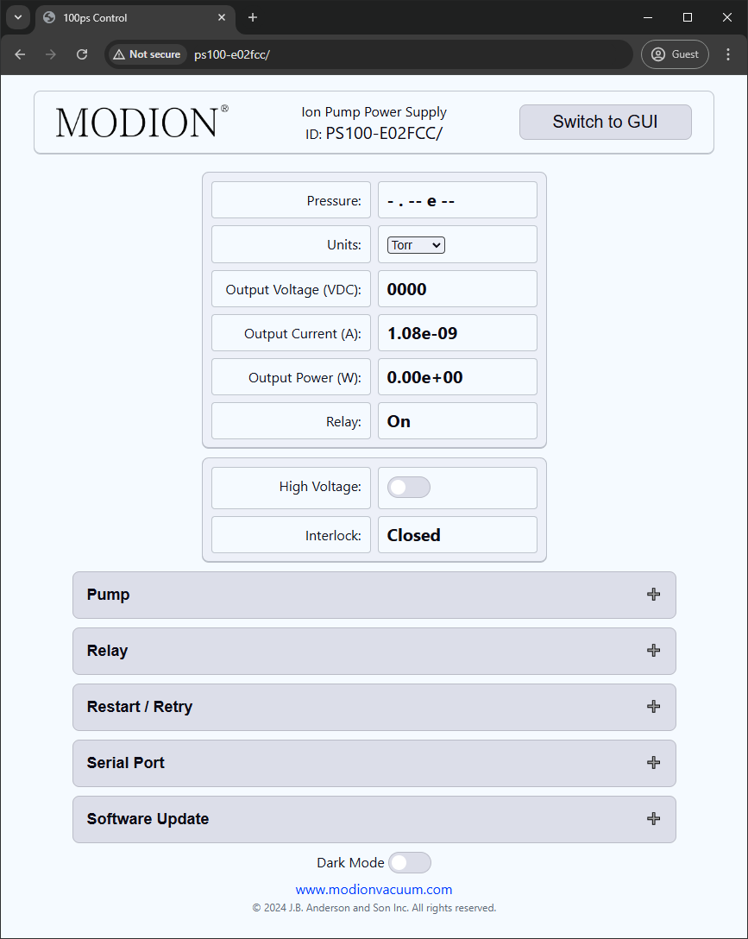
Once connected the power supply will load the HTML control page:
Figure 2.3.1-1: Web interface, HTML version
On this screen the power supply measurements are shown at the top and most of the settings can be accessed with the dropdowns in the lower section. By clicking on the “Switch to GUI” button shown at the top right it will load the GUI version of the web interface (next page):

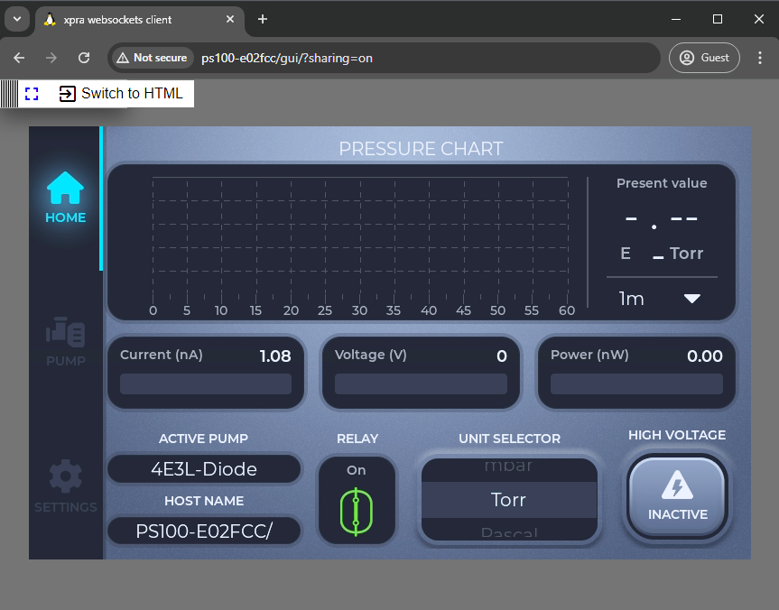
The GUI version of the web interface is simply a live video stream from the power supply’s display. It can be clicked on and operated in the same way as the touch screen on the power supply. Note that the click interface is not mobile-friendly, and it is recommended that when controlling from a mobile device to do so via the HTML version. Simply viewing the GUI version on mobile works well.
Figure 2.3.1-2: Web interface, GUI version

Serial Communications

Overview
This power supply can be controlled by either the RS-232 or RS-485 (half duplex) serial standards. See section J5 Serial Communications Connector^{(p19)} for the pinout of the serial connector, and section Serial Tab^{(p29)} for setting up connection parameters.
- The serial communication operates in controller/device mode and will not transmit any data without first receiving a command from the master.
- All data is sent and received with ASCII encoding.
- The maximum length of message that the power supply can receive and regard as valid is 128 characters.
- The only field where extra space characters may be sent is in the data field.
- Every message can be sent with an optional checksum.
- The power supply will always reply with a checksum.
These field definitions will be used in the following sections:
Field | Description | ASCII Representation | HEX Representation | Size
<START> | Start Character | ‘~’ (Tilda) | 0x7E | 1 character
<SP> | Space Character | ‘ ‘ (Space) | 0x20 | 1 character
<ID> | Device ID | “00” to “99” | (0x30 0x30) to (0x39 0x39) | 2 characters
<ERC> | Error Code | “00” to “FF” | (0x30 0x30) to (0x46 0x46) | 2 characters
<CMD> | Command Number | “01” to “FF” | (0x30 0x31) to (0x46 0x46) | 2 characters
<DATA> | Data Field | varies | varies | varies
<SUM> | Checksum | “00” to “FF” | (0x30 0x30) to (0x46 0x46) | 2 characters
<CR> | End of Transmission | ‘\r’  (Carriage Return) | 0x0D | 1 character
Figure 2.3.2-1: Serial coms field definitions

Command to Power Supply Message Structure
The format for sending a message to the power supply:
<START> | <SP> | <ID> | <SP> | <CMD> | <SP> | <DATA> | <SP> | <SUM> | <CR>
Figure 2.3.2-2: Serial coms Rx message structure, full
When the power supply receives a Start Character <START> it will start accepting any other characters sent until a Carriage Return <CR> is received. Any data received without a start character will be disregarded.
The Device ID <ID> field is only checked by the power supply when it is in RS-485 mode:
- In RS-485 mode the two digits must match the power supply’s device id, see section Serial Tab^{(p29)}, in order for the power supply to regard the message as valid and send a response.
- In RS-232 mode two digits still must be sent but any number will be regarded as valid, and the power supply will send a response.
After the power supply has received and checked the device ID, it is able to send a response. If any of the remaining message does not match the expected format, the power supply will respond with an error.
The Data Field <DATA> varies based on which command is being sent.
For commands with “None or Any” in the User Commands^{(p42)} table this field is ignored by the power supply and may be omitted entirely along with the following <SP> field. Alternatively, any data may be sent in the <DATA> field along with the <SP> field and the data will be ignored.
The optional format for “None or Any” commands:
<START> | <SP> | <ID> | <SP> | <CMD> | <SP> | <SUM> | <CR>
Figure 2.3.2-3: Serial coms Rx message structure, no data
Some commands are Read/Set commands. If the <DATA> and one <SP> field are omitted like above, it will be a read command. If the two fields are included, it will be a Set command. See the Example Serial Transactions^{(p39)} section for examples.
See the Checksum Calculation^{(p40)} section for instructions on calculating the checksum. As another option, if “00” is sent in the <SUM> field, the power supply will ignore the checksum and assume that it has received a good message.

Power Supply Response Message Structure
Once the power supply has received a command message it will respond with a message in this format. Note that a start character is unnecessary, since the computer that sent the command will be expecting a reply from the power supply:
<ID> | <SP> | “OK” or “ER” | <SP> | <ERC> | <SP> | <DATA> | <SP> | <SUM> | <CR>
Figure 2.3.2-4: Serial coms Tx message structure, full
If the power supply is replying to a command with a “None” reply in the User Commands^{(p42)} table, it will omit the <DATA> field and the following <SP> field:
<ID> | <SP> | “OK” or “ER” | <SP> | <ERC> | <SP> | <SUM> | <CR>
Figure 2.3.2-5: Serial coms Tx message structure, no data
If the command was successful:
- The third field will be “OK”.
- The <ERC> field will be “00”.
If the command resulted in an error:
- The third field will be “ER”.
- The <ERC> field will be the Error Code from the table below.
- The <DATA> field will be the Error Name from the table below.
Note that the power supply will not reply with an error unless it has at least received the start character and the correct <ID> field.
Error Code <ERC> | Error Name | Error Description
“00” | n/a | No error
“FF” | UNEDEFINED ERROR | An error occurred
“FD” | INVALID DATA | Invalid data received on a set command  (out of range, format, data missing)
“FC” | INVALID COMMAND | Invalid command number received
“FB” | BAD CHECKSUM | The received checksum does not match the received data
“FA” | INVAILID FORMAT | Invalid command format (space missing, extra digit, etc.)
“F9” | INCOMPLETE PACKET | The received command length is less than the minimum of:  ‘~’ + 9 characters + ‘\r’
“E1” | INTERLOCK OPEN | Attempt to enable HV with the interlock open
“E2” | BUILTIN PUMP SELECTED | Attempt to change pump data with a built-in pump selected
Figure 2.3.2-6: Serial coms Tx message error list

Checksum Calculation
The <SUM> or checksum field is calculated by:
- Summing the integer value of every character in the message:
  - For a command message to the power supply, this will be the first character after the <START> field and up to the last character before the <SUM> field. The first and last characters that will be included in the sum will always be space <SP> characters.
  - For the power supply’s reply message, this will be the first character in the message and up to the last character before the <SUM> field. The first character will always be the first digit in the <ID> field and the last character will always be a space <SP> character.
- Divide the sum by 256 (equal to 0x100 in hex) and the remainder of the division converted to hex is the checksum (modulo 256).
- The ASCII representation of the checksum is transmitted in the <SUM> field.
Checksum calculation for reply
from power supply for
command 3A with data=0
Character | Decimal  Value | Hex  Value
0 | 48 | 0x30
3 | 51 | 0x33
<SP> | 32 | 0x20
O | 79 | 0x4F
K | 75 | 0x4B
<SP> | 32 | 0x20
0 | 48 | 0x30
0 | 48 | 0x30
<SP> | 32 | 0x20

Sum of values = | 445 | 0x1BD
% 256 (0x100) = | 189 | 0xBD
Convert to Hex = | 0xBD | 0xBD
<SUM> In ASCII= | “BD” | “BD”

Checksum calculation for sending command 3A with data=0
Character | Decimal  Value | Hex  Value
~ | Do not sum <START>
<SP> | 32 | 0x20
0 | 48 | 0x30
3 | 51 | 0x33
<SP> | 32 | 0x20
3 | 51 | 0x33
A | 65 | 0x41
<SP> | 32 | 0x20
0 | 48 | 0x30
<SP> | 32 | 0x20

Sum of values = | 391 | 0x187
% 256 (0x100) = | 135 | 0x87
Convert to Hex = | 0x87 | 0x87
<SUM> In ASCII= | “87” | “87”

See the example on the next page for usage of the checksum.

Example Serial Transactions
All example commands assume the power supply’s device ID is set to 03, and all valid versions of each command are shown. <CR> is a carriage return character (‘\r’ or 0x0D); it is not sent as text. The response data and checksum will deviate from these examples based on the specific power supply’s parameters. See the Extended Example Serial Transactions^{(p46)} section for examples for more commands.
Request the power supply’s host name [Read command]:
 | ~ 03 01 00 A4<CR> | With “00” data field
or | ~ 03 01 24<CR> | The data field may be omitted for this command
or | ~ 03 01 00<CR> | The checksum may be ignored by sending “00”
The power supply will respond with:
03 OK 00 PS100-AD7A14/ CD<CR>

Enable the high voltage [Set command with ‘None or Any’ data]:
 | ~ 03 37 00 AD<CR> | With “00” data field
or | ~ 03 37 2D<CR> | The data field may be omitted for this command
or | ~ 03 37 00<CR> | The checksum may be ignored by sending “00”
The power supply will enable the high voltage and respond with:
03 OK 00 BD<CR>

Change the pressure units to Torr [Set command that requires data]:
 | ~ 03 0E T AC<CR>
or | ~ 03 0E T 00<CR> | The checksum may be ignored by sending “00”
The power supply will set the units to Torr and respond with:
03 OK 00 BD<CR>

Request if the setpoint relay is set above or below [Read / Set command without data]:
 | ~ 03 3A 37<CR> | This type of read may only be sent without data
or | ~ 03 3A 00<CR> | The checksum may be ignored by sending “00”
The power supply will respond with data of 1 which equals above:
03 OK 00 1 0E<CR>

Set the setpoint relay to be on below the setpoint [Read / Set command with data]:
 | ~ 03 3A 0 87<CR>
or | ~ 03 3A 0 00<CR> | The checksum may be ignored by sending “00”
The power supply will set the setpoint relay to be on below the setpoint and respond with:
03 OK 00 BD<CR>
Figure(s) 2.3.2-7: Example serial transactions

User Commands
Cmd.  Num. | Name and Description | Data | Response | Data Description
01 | HOST NAME  The power supplies host name | None or Any | "100PS-HHHHHH" | HHHHHH is 6 hex digits unique to a PS100.  The response is the host name used to connect via ethernet.
02 | VERSION  The power supply's software version | None or Any | "XX.XX.XXX" | X = Numeric 0-9
0A | READ CURRENT  Read the output current | None or Any | "X.XXE-XX AMPS" | X = Numeric 0-9
0B | READ PRESSURE  Read the pump pressure | None or Any | "X.XXE-XX CCC" | X =Numeric 0-9 | CCC = Torr, MBR, or PA  0.1E-10 = HV-Off or Waiting for accurate pressure
0C | READ VOLTAGE  Read the output voltage | None or Any | "XXXX" | X = Numeric 0-9
0E | SET UNITS  Sets the pressure units | "C" | None | C = T(Torr), M(mbar), P(Pascal)
0F | READ POWER  Read the output power | None or Any | "X.XXE-XX W" | X =Numeric 0-9
11 | READ PUMP SIZE  Read the pump size in liters per second | None or Any | "XXX.X L/S" | X = Numeric 0-9
13 | READ INTERLOCK STATUS  Read whether the interlock is  open or closed | None or Any | "X" | X = Numeric 0-1 | 0 = Open | 1 = Closed
1D | READ PRESS FACTOR  Read the pressure correction factor | None or Any | "X.XX" | X = Numeric 0-9
*1 Only user pumps can be modified, if a built-in pump is active and these commands are issued an error will be returned
20 | READ/SET ACTIVE PUMPS NAME ^{*1}  Read the active pumps name | None or Any | "pumps name" | String of alphanumeric,  can include symbols and spaces
21 | READ/SET PRESS FACTOR ^{*1}  Read / Set the active pump's pressure correction factor | None or "X.XX" | "X.XX" | X.XX = Numeric 0.01 to 9.99
22 | READ/SET CURRENT LIMIT ^{*1}  Read / Set the active pump's current limit | None or "XXX" | "XXX" | XXX = Numeric 5 to 100 mA
23 | READ/SET VOLTAGE LIMIT ^{*1}  Read / Set the active pump's voltage limit | None or "XXXX" | "XXXX" | XXXX = Numeric 500 to 5000 V
24 | READ/SET POWER LIMIT ^{*1}  Read / Set the active pump's power limit | None or "XXX" | "XXX" | XXX = Numeric 5 to 100 W
25 | READ/SET PUMP SIZE ^{*1}  Read / Set the active pump's size | None or "XXX.X" | "XXX.X" | XXX.X = Numeric 000.5 to 999.0 Liters per second
26 | READ NUMBER OF PUMPS  Read the total number of saved pumps | None or Any | "XXX" | XXX = Numeric 1 to 100
27 | READ NUMBER OF BUILT-IN PUMPS  Read the number of built-in pumps | None or Any | "XXX" | XXX = Numeric 1 to 100
28 | READ/SET SELECTED PUMP  Read / Set the active pump by index number (First pump is #0) | None or "X" | "XXX" | XXX = Numeric 0 to 100
*2 The interlock must be closed to enable HV, if it is open and this command is issued an error will be returned
37 | START HV ^{*2}  Enable high voltage | None or Any | None
38 | STOP HV  Disable high voltage | None or Any | None
3A | READ/SET RELAY ABOVE / BELOW  Read / Set if the relay will be ON above or below the setpoint | None or "X" | "X" | X = Numeric 0-1  0 = ON below the setpoint | 1 = ON above the setpoint
3B | READ RELAY STATUS  Read if the relay is off or on | None or Any | "X" | X = Numeric 0-1 | 0 = Off | 1 = On
3E | READ SETPOINT  Reads the relay setpoint | None or Any | "X.XXE-XX" | X = Numeric 0-9  1.00E-2 to 1.00E-14
3F | SET SETPOINT  Sets the relay setpoint | "X.XXE-XX" | None | X = Numeric 0-9  1.00E-2 to 1.00E-14
45 | READ WIFI MAC  Read the Wi-Fi MAC address | None or Any | "HH:HH:HH:HH:HH:HH" | H = Hex 0-F
*3 In case of missing / incorrect data this command will default to “9600,N,8,1”.
Understood baud rates are: 1200, 1800, 2400, 4800, 9600, 19200, 38400, 57600, 115200.
46 | READ/SET SERIAL PARAMETERS ^{*3}  Read / Set: Baud rate, parity, data bits, and stop bits. | None or  "B,P,D,S" | "B,P,D,S"  String delimited with ‘,’ | B = Baud rate  P = Parity (‘N’, ‘E’, ‘O’)  D = Data bits (‘6’, ‘7’, ‘8’)  S = Stop Bits (‘1’, ‘2’)
47 | READ IP ADDRESS  Read the active IP address, preferring ethernet | None or Any | “XXX.XXX.XXX.XXX” | X = Numeric 0-9
4A | READ ETHERNET MAC  Read the ethernet MAC address | None or Any | "HH:HH:HH:HH:HH:HH" | H = Hex 0-F
4B | READ/SET SERIAL STANDARD  Read / Set the serial standard | None or "X" | "X" | X = 0(RS232), 2(RS485)
61 | HV STATUS  Read if high voltage is on or off | None or Any | "X" | X = Numeric 0-1 | 0 = Off | 1 = On
62 | READ/SET SERIAL ID  Read / Set the power supply's serial ID | "XX" | None | X = Numeric 0-9  00 to 99
68 | SET POWER LOSS RESTART  See: Restart Tab^{(p28)} | "X" | None | X = Numeric 0-1  0 = Restart Disabled  1 = Restart Enabled
69 | READ POWER LOSS RESTART  Read the power loss restart setting | None or Any | "X" | X = Numeric 0-1  0 = Restart Disabled  1 = Restart Enabled
70 | READ/SET ARC RESTART  Read / Set arc retry on or off | None or "X" | "X" | X = Numeric 0-1  0 = Fault Retry Disabled  1 = Fault Retry Enabled
71 | READ/SET ARC RESTART NUMBER  See: Restart Tab^{(p28)} | None or "X" | "X" | X = Numeric 1-9  The number of times to retry before turning HV off
DA | READ HEAT SINK TEMP  Read the main heat sink temperature | None or Any | “XX.XX” | X = Numeric 0-9  In degrees C
DB | READ FAN SPEED  Read the currently set fan speed, in percent | None or Any | "XXX" | XXX = Numeric 0 to 100 %
Figure 2.3.3-1: User command table

ASCII Reference Table
Dec | Hex | Char |  | Dec | Hex | Char | Dec | Hex | Char | Dec | Hex | Char
0 | 0x00 | NUL | (null) | 32 | 0x20 | Space | 64 | 0x40 | @ | 96 | 0x60 | `
1 | 0x01 | SOH | (start of heading) | 33 | 0x21 | ! | 65 | 0x41 | A | 97 | 0x61 | a
2 | 0x02 | STX | (start of text) | 34 | 0x22 | " | 66 | 0x42 | B | 98 | 0x62 | b
3 | 0x03 | ETX | (end of text) | 35 | 0x23 | # | 67 | 0x43 | C | 99 | 0x63 | c
4 | 0x04 | EOT | (end of transmission) | 36 | 0x24 | $ | 68 | 0x44 | D | 100 | 0x64 | d
5 | 0x05 | ENQ | (enquiry) | 37 | 0x25 | % | 69 | 0x45 | E | 101 | 0x65 | e
6 | 0x06 | ACK | (acknowledge) | 38 | 0x26 | & | 70 | 0x46 | F | 102 | 0x66 | f
7 | 0x07 | BEL | (bell) | 39 | 0x27 | ' | 71 | 0x47 | G | 103 | 0x67 | g
8 | 0x08 | BS | (backspace) | 40 | 0x28 | ( | 72 | 0x48 | H | 104 | 0x68 | h
9 | 0x09 | TAB | (horizontal tab) | 41 | 0x29 | ) | 73 | 0x49 | I | 105 | 0x69 | i
10 | 0x0A | LF | (NL, line feed, new line) | 42 | 0x2A | * | 74 | 0x4A | J | 106 | 0x6A | j
11 | 0x0B | VT | (vertical tab) | 43 | 0x2B | + | 75 | 0x4B | K | 107 | 0x6B | k
12 | 0x0C | FF | NP, form feed, new page) | 44 | 0x2C | , | 76 | 0x4C | L | 108 | 0x6C | l
13 | 0x0D | CR | (carriage return) | 45 | 0x2D | - | 77 | 0x4D | M | 109 | 0x6D | m
14 | 0x0E | SOH | (shift out) | 46 | 0x2E | . | 78 | 0x4E | N | 110 | 0x6E | n
15 | 0x0F | SI | (shift in) | 47 | 0x2F | / | 79 | 0x4F | O | 111 | 0x6F | o
16 | 0x10 | DLE | (data link escape) | 48 | 0x30 | 0 | 80 | 0x50 | P | 112 | 0x70 | p
17 | 0x11 | DC1 | (device control 1) | 49 | 0x31 | 1 | 81 | 0x51 | Q | 113 | 0x71 | q
18 | 0x12 | DC2 | (device control 2) | 50 | 0x32 | 2 | 82 | 0x52 | R | 114 | 0x72 | r
19 | 0x13 | DC3 | (device control 3) | 51 | 0x33 | 3 | 83 | 0x53 | S | 115 | 0x73 | s
20 | 0x14 | DC4 | (device control 4) | 52 | 0x34 | 4 | 84 | 0x54 | T | 116 | 0x74 | t
21 | 0x15 | NAK | (negative acknowledge) | 53 | 0x35 | 5 | 85 | 0x55 | U | 117 | 0x75 | u
22 | 0x16 | SYN | (synchronous idle) | 54 | 0x36 | 6 | 86 | 0x56 | V | 118 | 0x76 | v
23 | 0x17 | ETB | (end of trans. Block) | 55 | 0x37 | 7 | 87 | 0x57 | W | 119 | 0x77 | w
24 | 0x18 | CAN | (cancel) | 56 | 0x38 | 8 | 88 | 0x58 | X | 120 | 0x78 | x
25 | 0x19 | EM | (end of medium) | 57 | 0x39 | 9 | 89 | 0x59 | Y | 121 | 0x79 | y
26 | 0x1A | SUB | (substitute) | 58 | 0x3A | : | 90 | 0x5A | Z | 122 | 0x7A | z
27 | 0x1B | ESC | (escape) | 59 | 0x3B | ; | 91 | 0x5B | [ | 123 | 0x7B | {
28 | 0x1C | FS | (file separator) | 60 | 0x3C | < | 92 | 0x5C | \ | 124 | 0x7C | |
29 | 0x1D | GS | (group separator) | 61 | 0x3D | = | 93 | 0x5D | ] | 125 | 0x7D | }
30 | 0x1E | RS | (record separator) | 62 | 0x3E | > | 94 | 0x5E | ^ | 126 | 0x7E | ~
31 | 0x1F | US | (unit separator) | 63 | 0x3F | ? | 95 | 0x5F | _ | 127 | 0x7F | DEL
Figure 2.3.3-2: ASCII reference table

Extended Example Serial Transactions
Command | Data | UseChkSum | CommandMessage | ReplyFromPS
01 | 00 | TRUE | ~ 03 01 00 A4 | 03 OK 00 PS100-E02FCC/ E0
01 |  | TRUE | ~ 03 01 24 | 03 OK 00 PS100-E02FCC/ E0
01 |  | FALSE | ~ 03 01 00 | 03 OK 00 PS100-E02FCC/ E0
02 | 00 | TRUE | ~ 03 02 00 A5 | 03 OK 00 0.2.25 02
02 |  | TRUE | ~ 03 02 25 | 03 OK 00 0.2.25 02
02 |  | FALSE | ~ 03 02 00 | 03 OK 00 0.2.25 02
0A | 00 | TRUE | ~ 03 0A 00 B4 | 03 OK 00 1.06e-09 AMPS EE
0A |  | TRUE | ~ 03 0A 34 | 03 OK 00 1.06e-09 AMPS EE
0A |  | FALSE | ~ 03 0A 00 | 03 OK 00 1.06e-09 AMPS EE
0B | 00 | TRUE | ~ 03 0B 00 B5 | 03 OK 00 0.1E-10 Torr 06
0B |  | TRUE | ~ 03 0B 35 | 03 OK 00 0.1E-10 Torr 06
0B |  | FALSE | ~ 03 0B 00 | 03 OK 00 0.1E-10 Torr 06
0C | 00 | TRUE | ~ 03 0C 00 B6 | 03 OK 00 0000 9D
0C |  | TRUE | ~ 03 0C 36 | 03 OK 00 0000 9D
0C |  | FALSE | ~ 03 0C 00 | 03 OK 00 0000 9D
0E | T | TRUE | ~ 03 0E T AC | 03 OK 00 BD
0E | T | FALSE | ~ 03 0E T 00 | 03 OK 00 BD
0F | 00 | TRUE | ~ 03 0F 00 B9 | 03 OK 00 0.00e+00 W 02
0F |  | TRUE | ~ 03 0F 39 | 03 OK 00 0.00e+00 W 02
0F |  | FALSE | ~ 03 0F 00 | 03 OK 00 0.00e+00 W 02
11 | 00 | TRUE | ~ 03 11 00 A5 | 03 OK 00 17 45
11 |  | TRUE | ~ 03 11 25 | 03 OK 00 17 45
11 |  | FALSE | ~ 03 11 00 | 03 OK 00 17 45
13 | 00 | TRUE | ~ 03 13 00 A7 | 03 OK 00 1 0E
13 |  | TRUE | ~ 03 13 27 | 03 OK 00 1 0E
13 |  | FALSE | ~ 03 13 00 | 03 OK 00 1 0E
1D | 00 | TRUE | ~ 03 1D 00 B8 | 03 OK 00 1.00 9C
1D |  | TRUE | ~ 03 1D 38 | 03 OK 00 1.00 9C
1D |  | FALSE | ~ 03 1D 00 | 03 OK 00 1.00 9C
20 | 00 | TRUE | ~ 03 20 00 A5 | 03 OK 00 Example Pump 6B
20 |  | TRUE | ~ 03 20 25 | 03 OK 00 Example Pump 6B
20 |  | FALSE | ~ 03 20 00 | 03 OK 00 Example Pump 6B
21 | 1.23 | TRUE | ~ 03 21 1.23 0A | 03 OK 00 BD
21 |  | TRUE | ~ 03 21 26 | 03 OK 00 1.23 A1
22 | 50 | TRUE | ~ 03 22 50 AC | 03 OK 00 BD
22 |  | TRUE | ~ 03 22 27 | 03 OK 00 50 42
23 | 3456 | TRUE | ~ 03 23 3456 1A | 03 OK 00 BD
23 |  | TRUE | ~ 03 23 28 | 03 OK 00 3456 AF
24 | 60 | TRUE | ~ 03 24 60 AF | 03 OK 00 BD
24 |  | TRUE | ~ 03 24 29 | 03 OK 00 60 43
25 | 123 | TRUE | ~ 03 25 123 E0 | 03 OK 00 BD
25 |  | TRUE | ~ 03 25 2A | 03 OK 00 123 73
26 | 00 | TRUE | ~ 03 26 00 AB | 03 OK 00 9 16
26 |  | TRUE | ~ 03 26 2B | 03 OK 00 9 16
26 |  | FALSE | ~ 03 26 00 | 03 OK 00 9 16
27 | 00 | TRUE | ~ 03 27 00 AC | 03 OK 00 7 14
27 |  | TRUE | ~ 03 27 2C | 03 OK 00 7 14
27 |  | FALSE | ~ 03 27 00 | 03 OK 00 7 14
28 | 7 | TRUE | ~ 03 28 7 84 | 03 OK 00 BD
28 |  | TRUE | ~ 03 28 2D | 03 OK 00 7 14
37 | 00 | TRUE | ~ 03 37 00 AD | 03 OK 00 BD
37 |  | TRUE | ~ 03 37 2D | 03 OK 00 BD
37 |  | FALSE | ~ 03 37 00 | 03 OK 00 BD
38 | 00 | TRUE | ~ 03 38 00 AE | 03 OK 00 BD
38 |  | TRUE | ~ 03 38 2E | 03 OK 00 BD
38 |  | FALSE | ~ 03 38 00 | 03 OK 00 BD
3A | 1 | TRUE | ~ 03 3A 1 88 | 03 OK 00 BD
3A |  | TRUE | ~ 03 3A 37 | 03 OK 00 BD
3B | 00 | TRUE | ~ 03 3B 00 B8 | 03 OK 00 1 0E
3B |  | TRUE | ~ 03 3B 38 | 03 OK 00 1 0E
3B |  | FALSE | ~ 03 3B 00 | 03 OK 00 1 0E
3E | 00 | TRUE | ~ 03 3E 00 BB | 03 OK 00 1.00e-09 97
3E |  | TRUE | ~ 03 3E 3B | 03 OK 00 1.00e-09 97
3E |  | FALSE | ~ 03 3E 00 | 03 OK 00 1.00e-09 97
3F | 1E-5 | TRUE | ~ 03 3F 1E-5 34 | 03 OK 00 BD
3F |  | TRUE | ~ 03 3F 3C | 03 ER FD INVALID DATA 45
45 | 00 | TRUE | ~ 03 45 00 AC | 03 OK 00 90:de:80:6d:0e:5a 5E
45 |  | TRUE | ~ 03 45 2C | 03 OK 00 90:de:80:6d:0e:5a 5E
45 |  | FALSE | ~ 03 45 00 | 03 OK 00 90:de:80:6d:0e:5a 5E
46 |  | TRUE | ~ 03 46 2D | 03 OK 00 19200,N,8,1 14
46 | 9600,N,8,1 | TRUE | ~ 03 46 9600,N,8,1 57 | 03 OK 00 BD
46 |  | TRUE | ~ 03 46 2D | 03 OK 00 9600,N,8,1 E7
47 | 00 | TRUE | ~ 03 47 00 AE | 03 OK 00 10.1.10.128 F5
47 |  | TRUE | ~ 03 47 2E | 03 OK 00 10.1.10.128 F5
47 |  | FALSE | ~ 03 47 00 | 03 OK 00 10.1.10.128 F5
4A | 00 | TRUE | ~ 03 4A 00 B8 | 03 OK 00 d8:3a:dd:e0:2f:cc EA
4A |  | TRUE | ~ 03 4A 38 | 03 OK 00 d8:3a:dd:e0:2f:cc EA
4A |  | FALSE | ~ 03 4A 00 | 03 OK 00 d8:3a:dd:e0:2f:cc EA
4B | 0 | TRUE | ~ 03 4B 0 89 | 03 OK 00 BD
4B |  | TRUE | ~ 03 4B 39 | 03 OK 00 0 0D
61 | 00 | TRUE | ~ 03 61 00 AA | 03 OK 00 0 0D
61 |  | TRUE | ~ 03 61 2A | 03 OK 00 0 0D
61 |  | FALSE | ~ 03 61 00 | 03 OK 00 0 0D
62 | 3 | TRUE | ~ 03 62 3 7E | 03 OK 00 BD
62 |  | TRUE | ~ 03 62 2B | 03 OK 00 03 40
68 | 1 | TRUE | ~ 03 68 1 82 | 03 OK 00 BD
68 |  | TRUE | ~ 03 68 31 | 03 ER FD INVALID DATA 45
69 | 00 | TRUE | ~ 03 69 00 B2 | 03 OK 00 1 0E
69 |  | TRUE | ~ 03 69 32 | 03 OK 00 1 0E
69 |  | FALSE | ~ 03 69 00 | 03 OK 00 1 0E
70 | 1 | TRUE | ~ 03 70 1 7B | 03 OK 00 BD
70 |  | TRUE | ~ 03 70 2A | 03 OK 00 1 0E
71 | 5 | TRUE | ~ 03 71 5 80 | 03 OK 00 BD
71 |  | TRUE | ~ 03 71 2B | 03 OK 00 5 12
DA | 00 | TRUE | ~ 03 DA 00 C8 | 03 OK 00 34.75 DE
DA |  | TRUE | ~ 03 DA 48 | 03 OK 00 34.75 DE
DA |  | FALSE | ~ 03 DA 00 | 03 OK 00 34.75 DE
DB | 00 | TRUE | ~ 03 DB 00 C9 | 03 OK 00 0 0D
DB |  | TRUE | ~ 03 DB 49 | 03 OK 00 0 0D
DB |  | FALSE | ~ 03 DB 00 | 03 OK 00 0 0D
Figure 2.3.3-3: Extended example serial transactions table

MODION®
J.B. Anderson and Son, Inc.
115 Railroad Street, Irwin, PA 15642
724-523-9610 // sales@modionvacuum.com

